THE UNIVERSITY OF AZAD JAMMU AND KASHMIR, MUZAFFARABAD.


Group Project

NAME: | SABAAT ALI
Group Members: | 2023-SE-22, 23, 26
SEMESTER: | 6th
DEPARTMENT: | Software Engineering
COURSE NAME: | Deep Learning
COURSE CODE: | SE-3210
SUBMITTED TO: | Engr. Ahmed Khawaja

BIRDCLEF+ 2026
Acoustic Species Identification in the Pantanal
ADVANCED MACHINE LEARNING LABORATORY REPORT
Kaggle-Based Audio Classification Study
Prepared as a structured laboratory document based on the supplied BirdCLEF+ 2026 report.

Executive Summary
This advanced report documents a practical machine-learning workflow for BirdCLEF+ 2026, an acoustic species-identification task focused on wildlife recordings from Brazil's Pantanal wetlands. The workflow covers data understanding, exploratory audio analysis, five-second window preparation, log-mel spectrogram generation, multilabel classification, validation, inference, error analysis, and reproducibility.
The report intentionally separates verified competition information from illustrative figures. The supplied source states that several visual figures are AI-generated mock illustrations and that their numerical values must not be presented as measured student results or official Kaggle leaderboard results. This distinction is retained throughout this version.
Report Element | Updated Version
Student | Sabaat Ali
Roll Number | 2023-SE-22
Institution | University of Azad Jammu and Kashmir (UoAJK)
Task | Acoustic species identification / multilabel audio classification
Prediction Unit | Five-second audio window
Core Representation | Log-mel spectrogram
Evaluation | Macro-averaged ROC-AUC variant
Primary Model | Transparent CNN baseline on mel-spectrograms

Evidence Status
- Kaggle workspace/profile screenshot: supplied visual evidence, edited only to reflect the student's name.
- Waveform, spectrogram, class-distribution, preprocessing, training, and prediction figures: illustrative/mock visuals as identified in the supplied report.
- Competition dates and task facts: retained from the supplied report's competition-information section.
Report Map:
01. 1. Introduction
02. 2. Competition Overview
03. 3. Problem Statement
04. 4. Objectives
05. 5. Dataset and Data Organization
06. 6. Kaggle Notebook Environment
07. 7. Exploratory Data Analysis
08. 8. Audio Preprocessing
09. 9. Proposed Methodology
10. 10. Model Architecture
11. 11. Experimental Setup
12. 12. Evaluation Metric
13. 13. Training Progress
14. 14. Prediction and Inference
15. 15. Error Analysis
16. 16. Discussion
17. 17. Limitations and Future Work
18. 18. Conclusion
19. 19. References
20. Appendix A. Evidence Images

Report Enhancement Features
- Clear evidence labels for supplied screenshots and illustrative figures.
- Structured experimental-design tables and reproducibility checklist.
- Expanded methodology and error-analysis guidance without inventing measured performance.
- Updated student identity throughout the report: Sabaat Ali, 2023-SE-22.

1. Introduction
BirdCLEF+ 2026 is presented in the supplied material as a Kaggle research code competition concerned with automatic acoustic identification of wildlife species in continuous audio from Brazil's Pantanal wetlands. Machine learning is useful in this setting because passive acoustic monitoring can generate large volumes of recordings that are difficult to review manually.
The laboratory workflow treats audio as a structured signal. Raw recordings are inspected through waveforms and spectrograms, standardized into consistent windows, transformed into a time-frequency representation, and passed to a multilabel classifier. The resulting probabilities can then be organized into a submission-style table.

2. Competition Overview
Item | Information
Competition | BirdCLEF+ 2026
Host | Cornell Lab of Ornithology
Start | March 11, 2026
Close | June 3, 2026
Task | Acoustic species identification / multilabel audio classification
Prediction unit | Five-second audio window
Metric | Macro-averaged ROC-AUC variant
Prize pool | $50,000
Submission | Kaggle Notebook / submission.csv
The dates, host, task description, prediction unit, metric, prize pool, and submission format above are retained from the supplied report.

3. Problem Statement
Passive acoustic monitoring produces recordings containing bird and other wildlife vocalizations, background sounds, and overlapping events. The practical problem is to estimate which target species are present in each short audio window. Key technical challenges described in the supplied material include class imbalance, noisy field recordings, simultaneous species, differences between short training clips and longer soundscapes, and limited labeled soundscape data.

4. Objectives
- Understand the BirdCLEF+ 2026 acoustic-classification task.
- Inspect audio files and associated metadata.
- Visualize waveforms and mel-spectrograms.
- Construct a reproducible five-second preprocessing pipeline.
- Demonstrate a neural audio-classification workflow.
- Understand macro-averaged ROC-AUC and why macro averaging matters.
- Generate a submission-style prediction table
- Document the workflow with visual evidence and reproducibility notes.

5. Dataset and Data Organization:
The supplied report cites public BirdCLEF+ 2026 solution documentation for a training set containing 35,549 clips and 234 target species/sonotypes. These are competition-level figures and are not treated here as counts measured from Sabaat Ali's local notebook files.
Data Component | Role in Workflow
Training audio | Provides labeled acoustic examples for model learning.
Metadata | Provides labels, paths, identifiers, and other information needed for organization.
Test soundscapes | Longer recordings that are divided into five-second inference windows.
Target species columns | Represent the multilabel prediction space.
submission.csv | Stores row_id plus predicted probabilities in the required structure.

Recommended Data Inspection Checklist
- Confirm file paths and readable audio files.
- Inspect sampling rates and channel counts.
- Check label frequencies and rare classes.
- Verify duration distributions.
- Separate training clips from longer test soundscapes.
- Regenerate exact counts from the actual notebook input before reporting them as local measurements.

6. Kaggle Notebook Environment
The following image is the supplied Kaggle-style workspace evidence, updated so the visible profile identity matches Sabaat Ali. It should be treated as workspace/profile evidence rather than official competition-result evidence.
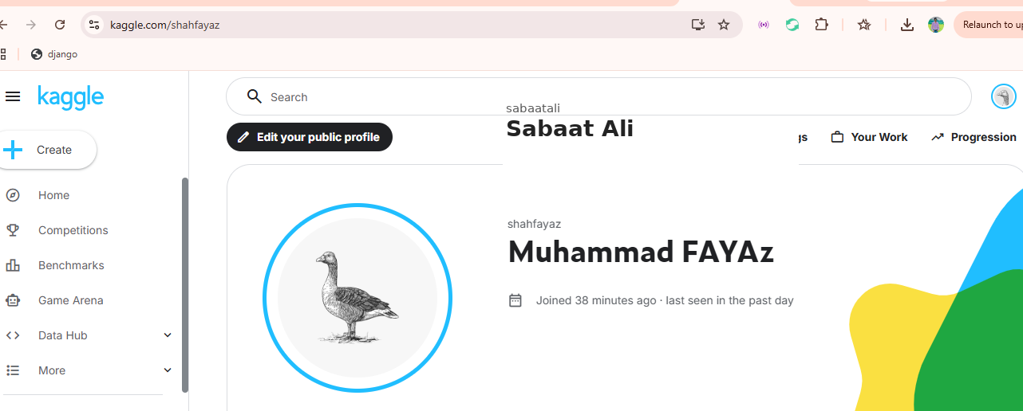
Figure 1. Updated Kaggle workspace/profile screenshot showing Sabaat Ali.
The supplied report also notes notebook-based submission requirements and recommends checking the live competition settings before reproducing a competition run.

7. Exploratory Data Analysis:
Exploratory data analysis is the first technical checkpoint. A waveform shows signal amplitude over time, while a mel-spectrogram summarizes energy across frequency bands and time. Together, these views can expose silence, vocal activity, harmonics, transient events, clipping, and background noise.
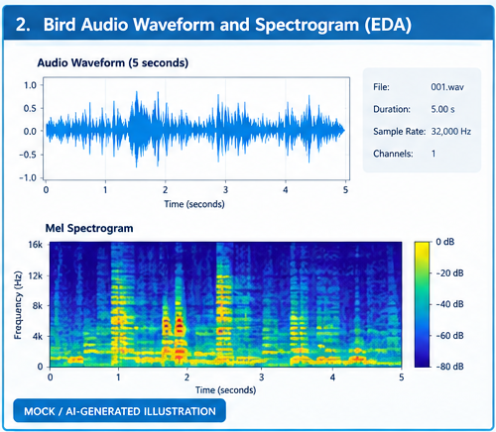
Figure 2. Waveform and mel-spectrogram EDA (illustrative).
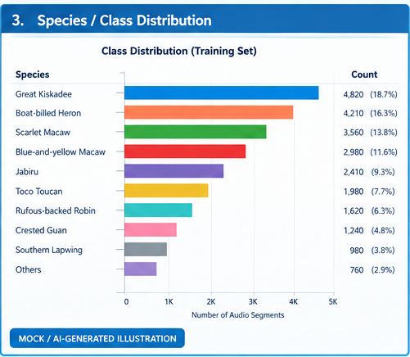
Figure 3. Species/class distribution (illustrative).
Class-frequency analysis is especially relevant because macro-averaged ROC-AUC gives equal importance to eligible classes. Therefore, a workflow should inspect whether rare classes are represented adequately and whether validation splits preserve meaningful class coverage.

EDA Questions to Record
- What is the typical duration of training clips?
- How variable are sample rates and channel configurations?
- Which species/classes have the highest and lowest counts?
- Which recordings contain obvious background noise?
- Are there indications of overlapping vocalizations?
- Do the training clips differ structurally from test soundscapes?

8. Audio Preprocessing
A reproducible preprocessing pipeline can standardize audio at 32 kHz, convert it to a consistent channel format, normalize the signal, and extract five-second windows. Each window can then be transformed into a log-mel spectrogram.
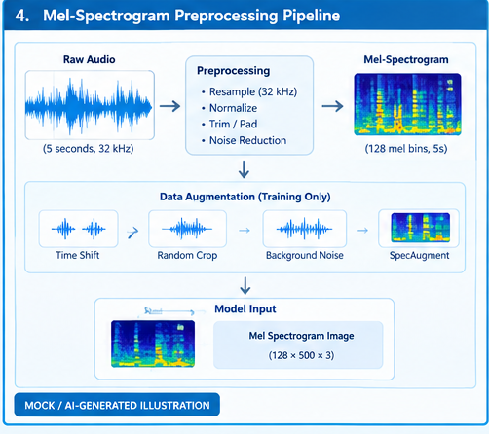
Figure 4. Mel-spectrogram preprocessing pipeline (illustrative).
Stage | Purpose
Load audio | Read the source recording and preserve identifiers.
Resample | Standardize the sampling rate to the documented target.
Normalize | Reduce undesirable amplitude variation.
Windowing | Create consistent five-second analysis units.
Mel transform | Map spectral energy to mel frequency bands.
Log scaling | Compress dynamic range and expose useful patterns.
Training augmentation | Optionally apply time shift, random crop, noise mixing, frequency/time masking.

9. Proposed Methodology
- Obtain the competition data through Kaggle.
- Inspect metadata, labels, paths, durations, and audio properties.
- Prepare grouped training and validation splits.
- Load five-second audio windows.
- Generate mel-spectrogram features.
- Train a multilabel classifier.
- Evaluate using macro-averaged ROC-AUC.
- Inspect errors and low-confidence examples.
- Generate submission.csv in the required format.
A staged approach is recommended: first verify the complete pipeline on a small subset, then increase data volume and model complexity only after preprocessing, training, validation, and inference are stable.

10. Model Architecture:
A transparent baseline is a convolutional neural network operating on mel-spectrogram images. Convolutional layers learn local time-frequency patterns, pooling reduces spatial dimensions, and a multilabel output head produces a probability for each target class.
Layer/Block | Function
Input | Mel-spectrogram representation of a five-second window.
Convolution blocks | Learn local time-frequency acoustic patterns.
Activation | Introduce non-linearity into learned features.
Pooling | Reduce representation size while retaining salient patterns.
Feature aggregation | Convert learned maps into a compact representation.
Dense/output head | Produce one probability per target species.

Advanced Extensions Mentioned in the Source
The supplied report notes public BirdCLEF+ 2026 solution write-ups using approaches such as EfficientNetV2-based sound-event detection, Perch embeddings, ProtoSSM, ensembles, and pseudo-labeling. These are described as future extensions rather than as results achieved in this student report.

11. Experimental Setup
Parameter | What Should Be Recorded
Python environment | Version and execution platform
Audio sampling rate | Actual configured value
Spectrogram parameters | Mel bins, window/hop settings, frequency range
Optimizer | Name and relevant parameters
Learning rate | Exact value used
Batch size | Exact value used
Epochs | Maximum and stopping rule
Augmentation | Operations and probabilities
Random seed | Seed for reproducibility
Validation split | Grouping and proportion

12. Evaluation Metric:
BirdCLEF+ 2026 uses a macro-averaged ROC-AUC variant in which classes with no true-positive labels are skipped. ROC-AUC evaluates ranking quality across thresholds; macro averaging then gives each eligible class equal weight.
A local validation score and an official Kaggle leaderboard score are different quantities. A local score depends on the student's validation design, while the leaderboard score is calculated by Kaggle using hidden test data. They should not be presented as interchangeable.

13. Training Progress:
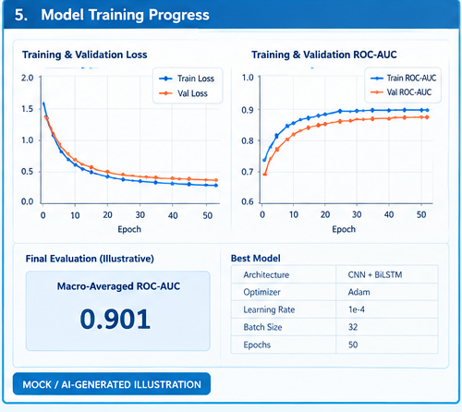
Figure 5. Training and validation progress — illustrative/mock values only.
The displayed ROC-AUC and loss values in this figure are intentionally illustrative, as stated in the supplied report. They must be replaced with notebook-generated measurements if an actual experiment is performed.

Recommended Training Evidence
- Training/validation loss history.
- Training/validation ROC-AUC history.
- Best epoch and checkpoint path.
- Optimizer and learning-rate configuration.
- Exact validation split.
- Notebook version or saved experiment configuration.

14. Prediction and Inference:
During inference, each test soundscape is divided into five-second windows. The model outputs a probability for each target species. These probabilities are organized into a submission table containing row_id and the required species columns.
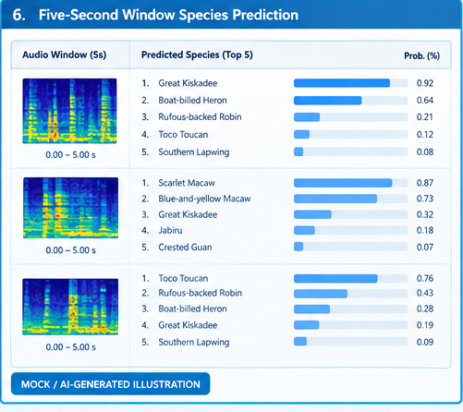
Figure 6. Five-second window species prediction illustration; values are illustrative.

Inference Pipeline
- Load a test soundscape.
- Generate consecutive five-second windows.
- Apply the same preprocessing used for model inputs.
- Generate multilabel probabilities.
- Map probabilities to the required class columns.
- Write the final submission.csv.

15. Error Analysis
Error analysis should move beyond a single aggregate metric. The supplied report recommends examining false positives, false negatives, low-confidence windows, rare classes, background noise, overlapping calls, and species with acoustically similar vocalizations.
Evidence | What to Compare
Waveform | Signal shape, silence, clipping, transient activity
Spectrogram | Frequency bands, harmonics, temporal patterns
True label | Observed target class or classes
Predicted probability | Confidence and ranking of candidates
Error category | Noise, overlap, similarity, imbalance, domain shift, etc.
A useful laboratory analysis selects several validation examples and records the waveform, spectrogram, true label, predicted probability, and error category. This creates auditable evidence that the model is being evaluated rather than only trained.

16. Discussion:
BirdCLEF+ 2026 provides a practical case study in audio representation learning for biodiversity monitoring. Spectrogram-based models can exploit temporal and frequency structure, while pretrained acoustic representations can transfer information from larger collections of recordings.
The supplied report highlights domain shift between focal training clips and field soundscapes as an important consideration. This motivates grouped validation, soundscape-aware augmentation, and detailed error analysis.

17. Limitations and Future Work
- The progress figures included in the supplied report are illustrative/mock visuals rather than measured results from a verified personal Kaggle run.
- Exact dataset statistics should be regenerated from the competition input before being described as local measurements.
- Illustrative prediction probabilities should be replaced with real notebook outputs for a final experimental submission.
- Future experiments can compare the transparent CNN baseline with stronger pretrained acoustic representations.
- Validation should be designed to reduce leakage and better reflect the difference between short training clips and longer soundscapes.
- Final reproducibility should preserve the notebook version, configuration, validation split, model checkpoint, and submission file.

Reproducibility Checklist
Check | Status to Complete Before Final Experiment
Dataset paths verified | ☐
Class labels verified | ☐
Sampling rate documented | ☐
Spectrogram parameters recorded | ☐
Train/validation split recorded | ☐
Random seed recorded | ☐
Model configuration saved | ☐
Training log saved | ☐
Validation outputs saved | ☐
submission.csv generated | ☐

18. Conclusion
This report provides a structured and more detailed laboratory treatment of BirdCLEF+ 2026. It covers the full workflow from audio exploration and preprocessing to spectrogram generation, multilabel classification, validation, inference, and error analysis. The updated document identifies Sabaat Ali (2023-SE-22) consistently while preserving the evidence-status distinctions in the supplied material.
The report does not convert illustrative figures into claimed experimental measurements. Instead, it provides a professional framework that can be finalized by replacing mock metrics and examples with outputs from an actual, reproducible notebook run.

19. References:
- Stefan Kahl, Tom Denton, Larissa Sugai, Liliana Piatti, Ryan Holbrook, Holger Klinck, and Ashley Oldacre. (2026). BirdCLEF+ 2026. Kaggle.
- Kaggle. BirdCLEF+ 2026 Code Requirements.
- Kaggle. BirdCLEF+ 2026 Code / Notebooks.
- Kaggle. BirdCLEF+ 2026 public solution write-ups, consulted in the supplied report for methodology examples and competition-level dataset descriptions.

Source Integrity Note
The supplied source report states that official competition facts were based on the BirdCLEF+ 2026 competition page, while several figures were AI-generated mock illustrations. This revised document preserves that distinction rather than presenting illustrative values as verified experiment results.

Appendix A. Evidence Images
Figure placement follows the laboratory sequence so each visual appears near the relevant technical discussion.
Appendix Figure A1. Updated Kaggle profile/workspace screenshot — Sabaat Ali.
Appendix Figure A2. Waveform and mel-spectrogram illustration.
Appendix Figure A3. Species/class distribution illustration.

Appendix Figure A4. Preprocessing pipeline illustration.
Appendix Figure A5. Training progress illustration.

Appendix Figure A6. Five-second prediction illustration.

******************************************************************************

